Layout of rally locations in the town of Murroe

Parc ferma
HQ and paper Scrutiny @ community hall

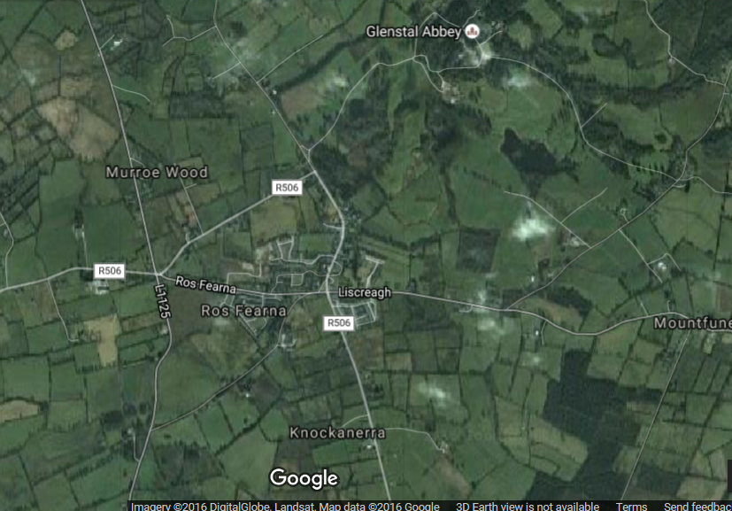

Scrutiny area @ Crokers bar
Trailer park

